Sustainability Report

Description | Remarks | Link
SDG 1: No Poverty  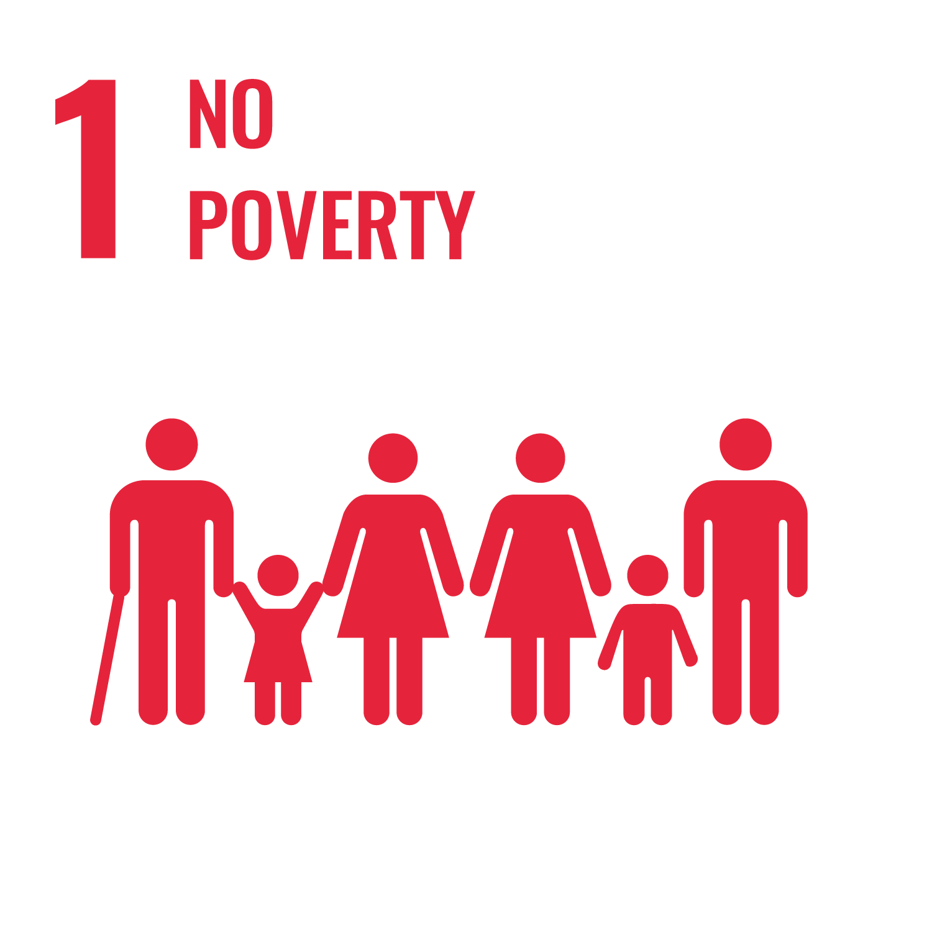 | - SRHU has been empowering rural communities through sustainable livelihood programs:  - Trained 5,000+ farmers in organic and aromatic crop cultivation.  - Promotes sustainable livelihoods and self-reliance in rural areas.  - Supports income generation through skill development and entrepreneurship.  - Contributes directly to poverty reduction and community resilience. | No Poverty
SDG 2: Zero Hunger  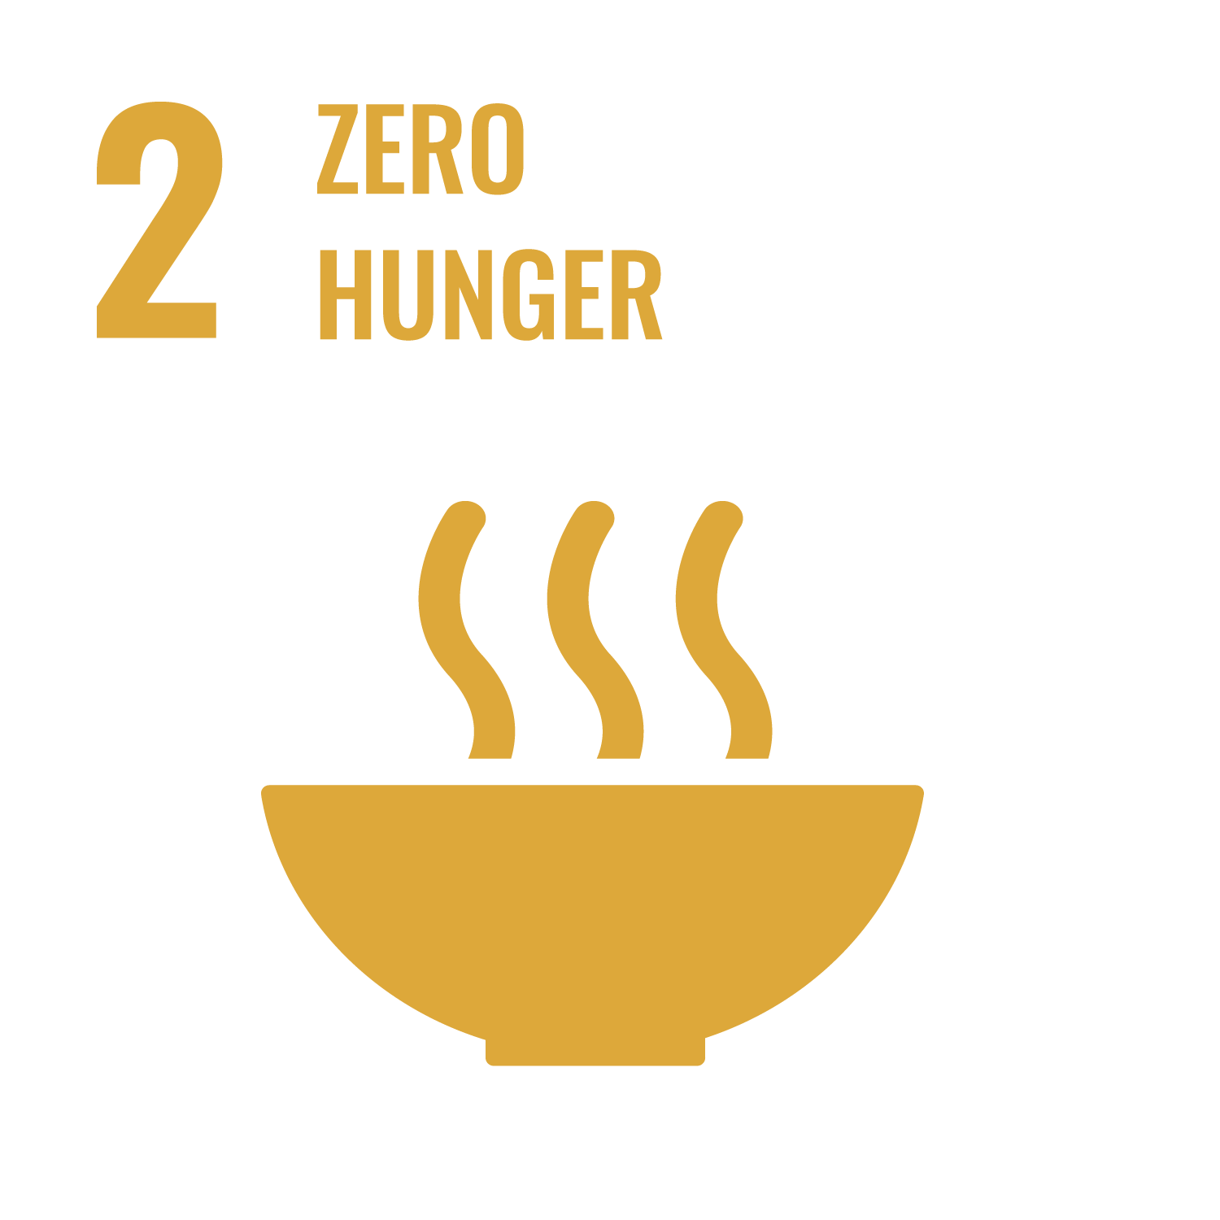 | - SRHU empowers rural farmers by providing training, enhancing yield quality, and promoting food security.  - The university promotes nutrition and income through sustainable farming practices and direct market linkages, supporting local livelihoods.  - Skill-building initiatives from the Rural Development Institute (RDI) also support food sustainability, equipping youth with agricultural and vocational training. | Zero Hunger
SDG 3: Good Health and Well-being  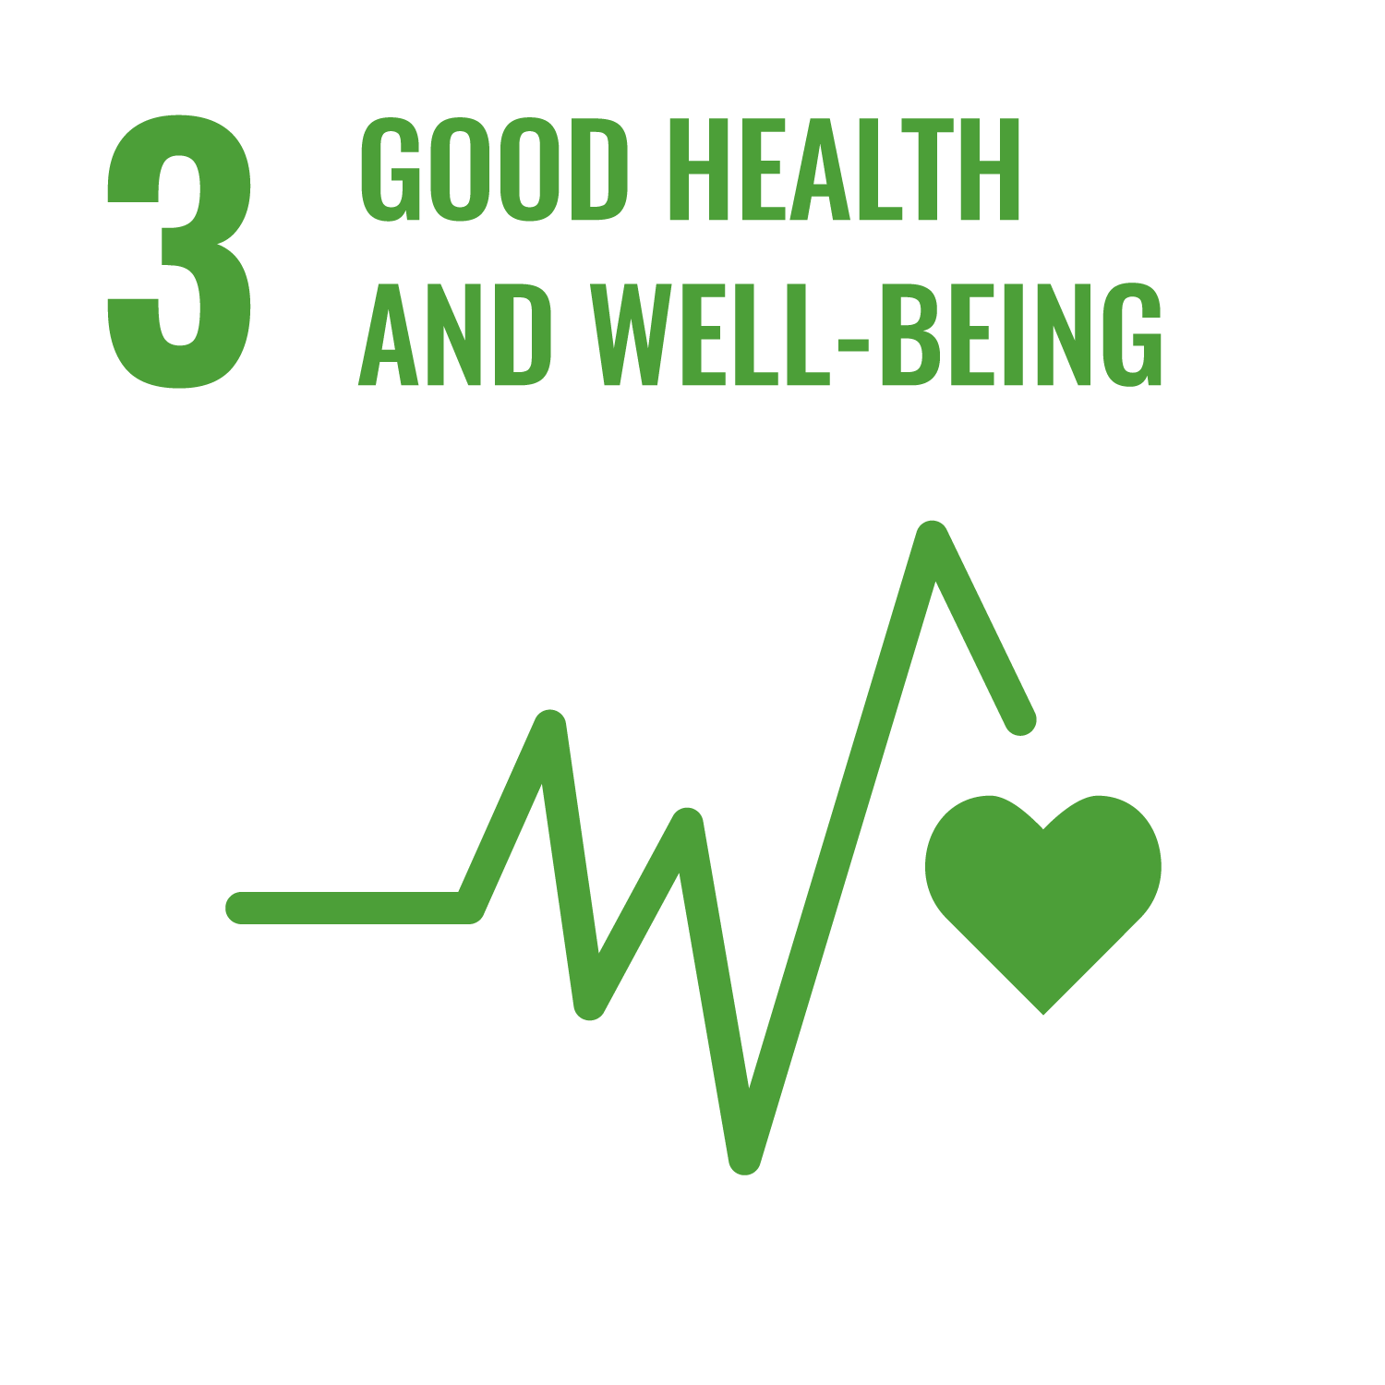 | - The Himalayan Hospital offers comprehensive healthcare through a 1,200-bed NABH-accredited hospital, AYUSH clinics, and a state-of-the-art Skill & Simulation Centre—the first of its kind in Uttarakhand.  - Promotes holistic health with yoga, lifestyle education, and learning disability support services for children.  - Leads over 50+ funded health research projects and multiple national/international collaborations addressing cancer, NCDs, maternal–child health, and diagnostics.  - Conducts wide-reaching outreach: community health camps, vaccination drives, maternal–child programs, and health education across 60+ medical courses. | Good Health and Well-being  Certificates of Appreciation
SDG 4: Quality Education  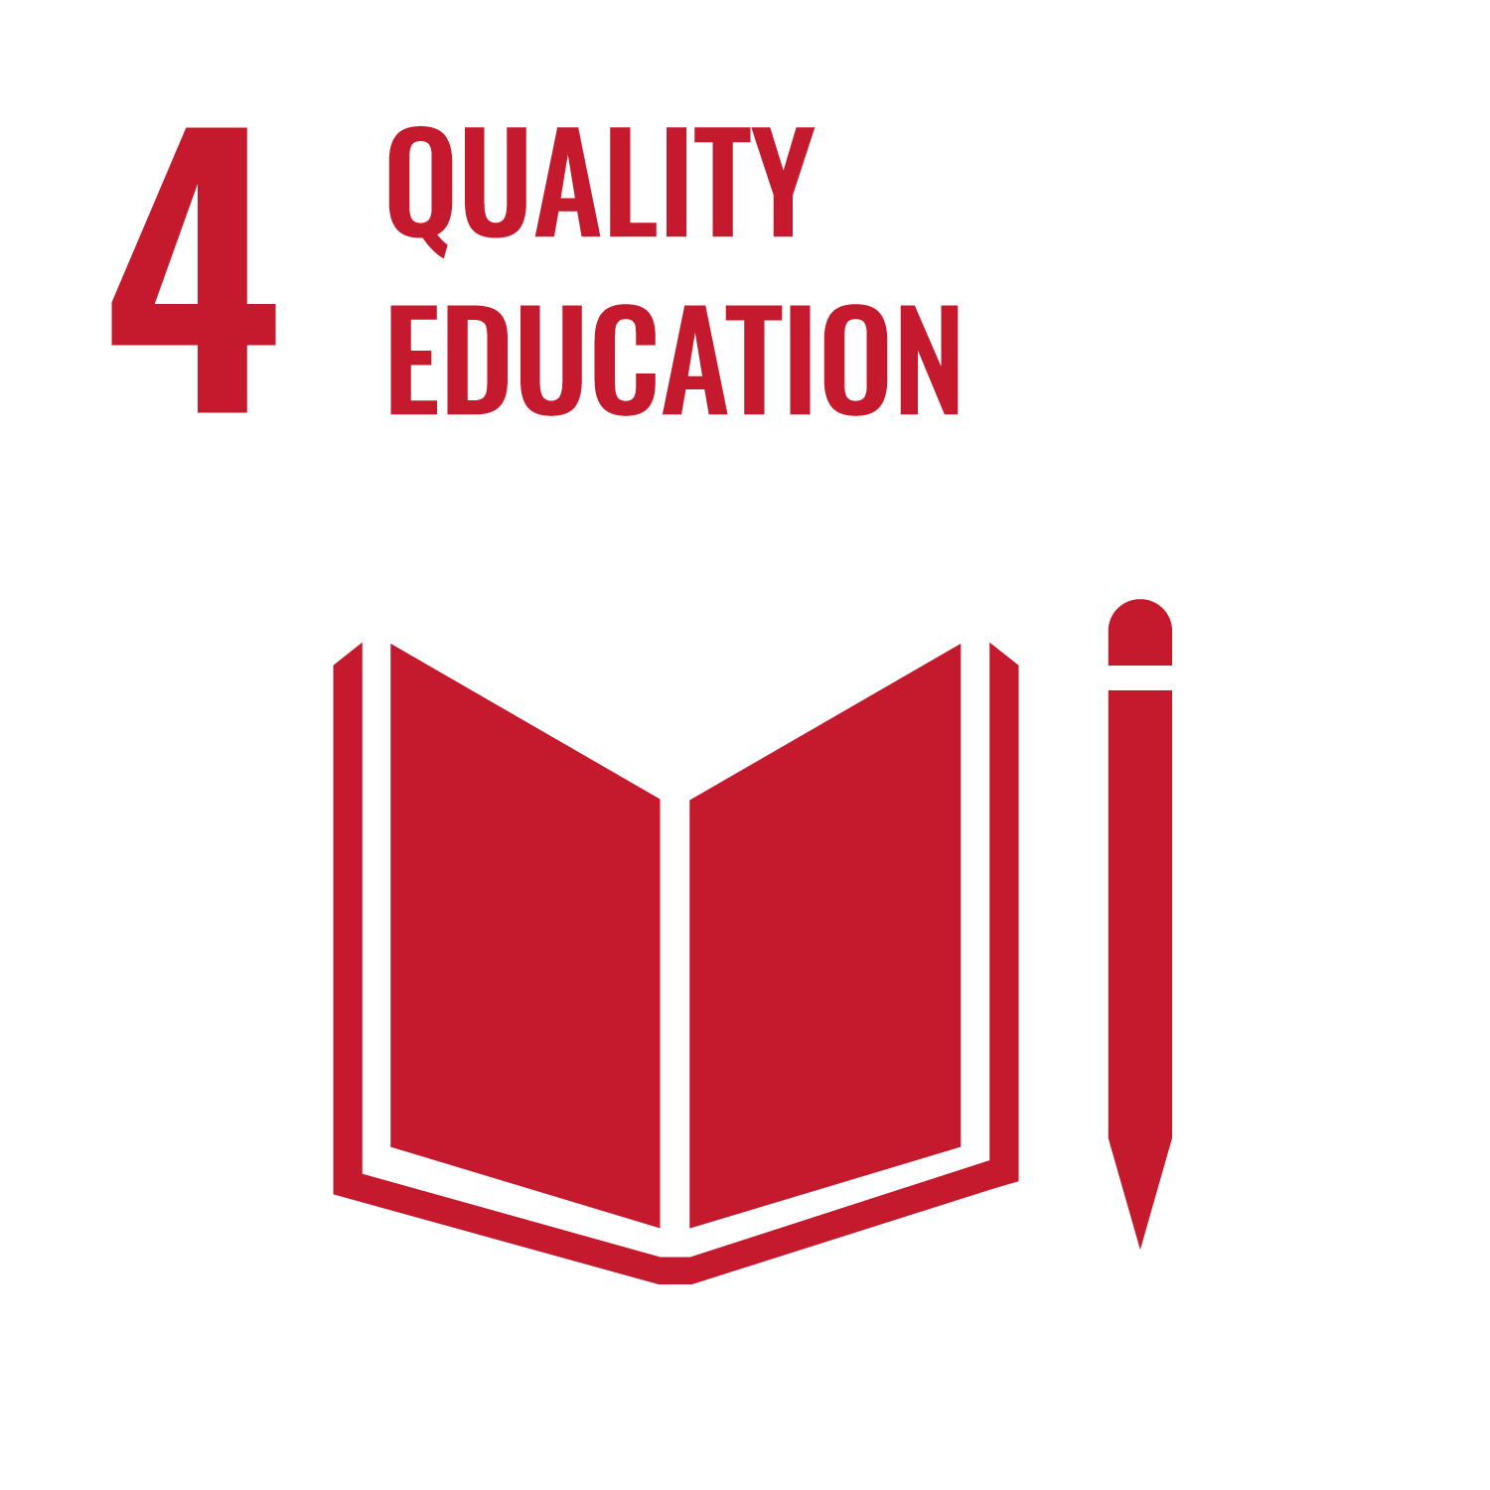 | - SRHU offers inclusive, holistic education from primary to higher levels, integrating modern science with traditional wisdom.  - With 4,743+ skill-oriented courses, adaptive learning, ICT-enabled classrooms, and MOOCs, it fosters lifelong learning.  - Scholarships, inclusive infrastructure, and assistive technologies ensure access for all, especially underprivileged and differently-abled students.  - Internships, faculty development, research, and global partnerships enhance competency, employability, and innovation. | Quality Education  Web link for LMS
SDG 5: Gender Equality  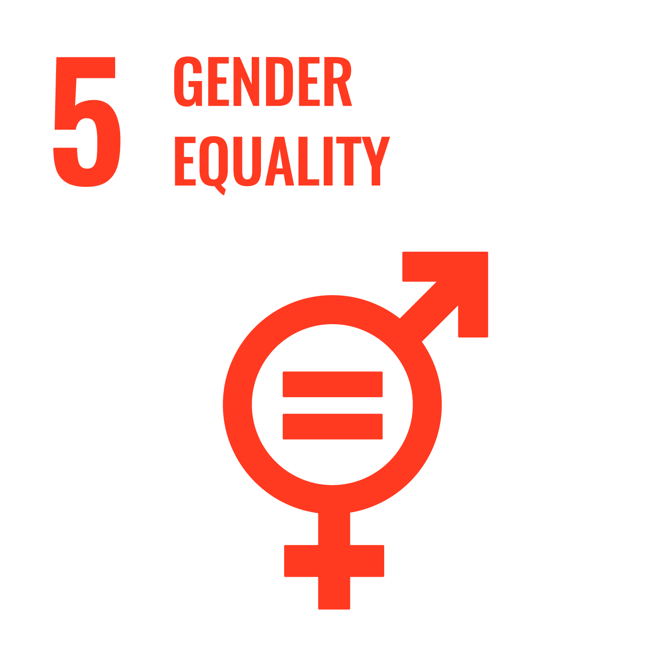 | - SRHU integrates gender sensitivity across more than 200 courses and conducts regular training for staff and students to challenge stereotypes and biases.  - It ensures a safe, inclusive campus through CCTV surveillance, ICCs, maternity leave, childcare, and sanitary facilities.  - Women’s empowerment is supported via scholarships, research leadership, STEM inclusion, and large-scale outreach in rural health and education.  - Special focus is placed on women's health through breast cancer awareness, menopause clinics, and reproductive care in underserved areas. | Gender Equality  Internal Complaints Committee
SDG 6: Clean Water and Sanitation  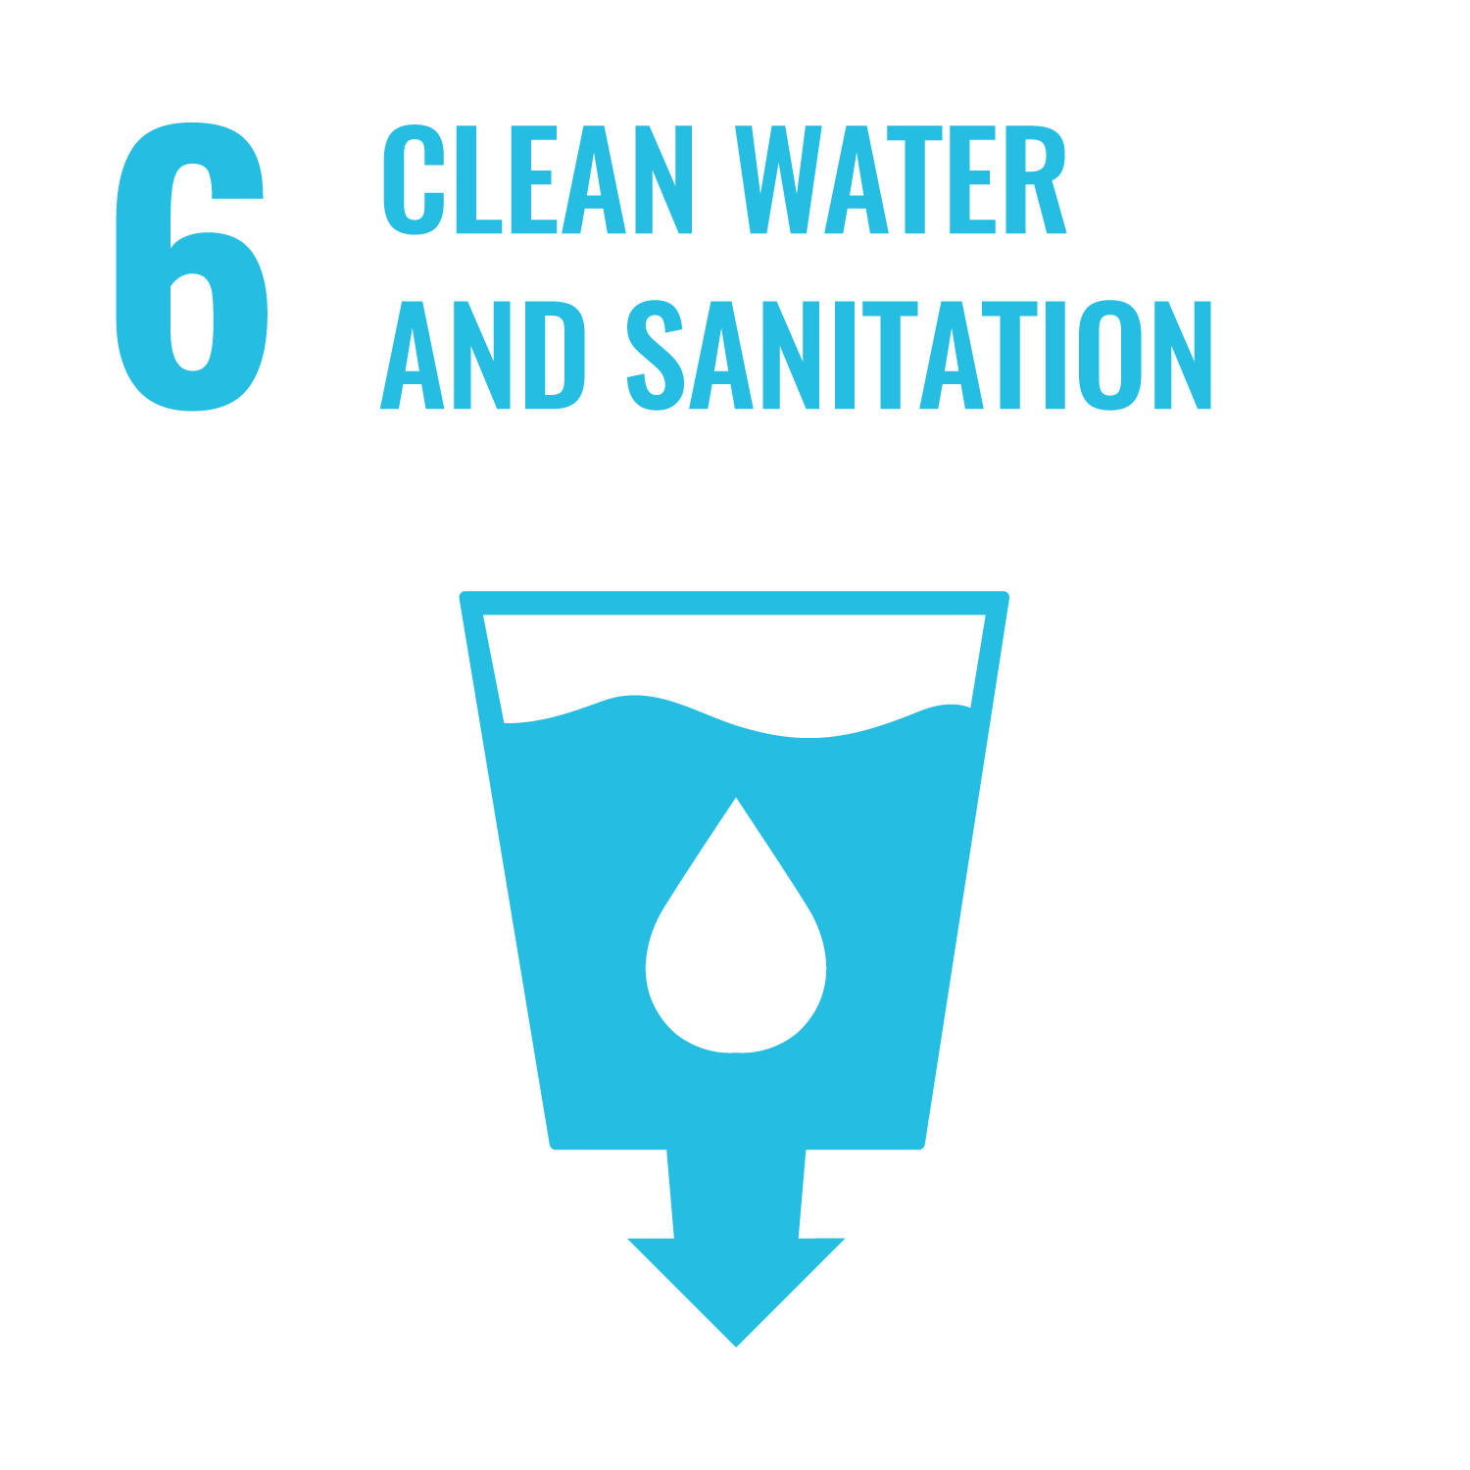 | - SRHU ensures sustainable water use through rainwater harvesting, greywater recycling, and groundwater recharge systems across campus.  - It empowers over 550 rural villages through WASH programs, community training, and partnerships under the Jal Jeevan Mission.  - Advanced wastewater treatment, policy-driven management, and innovative patents (e.g., IoT irrigation) reflect its research-driven approach.  - Nationwide capacity-building programs have trained 5,000+ officials and engineers on water supply, aquifer recharge, and sanitation resilience. | Clean Water and Sanitation  Appreciation letters
SDG 7: Affordable and Clean Energy  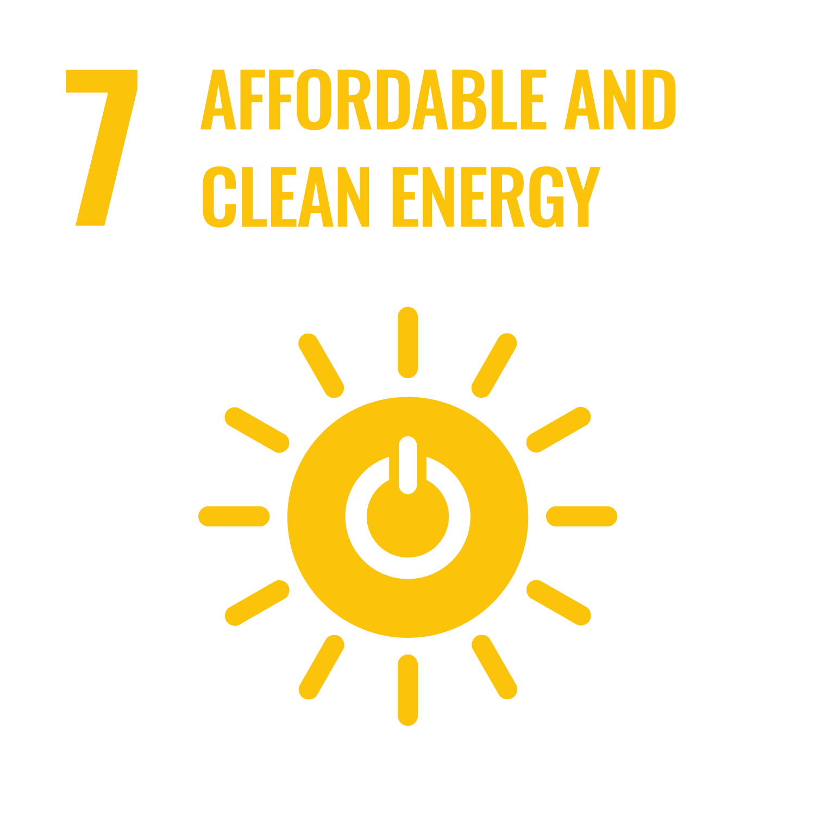 | - SRHU powers sustainability through a 2500 kW rooftop solar plant and a campus biogas unit, saving LPG and reducing emissions.  - Implements LED lighting, BLDC fans, BEE-rated appliances, and sensor-based systems to boost energy efficiency.  - Promotes a green campus with electric vehicles, restricted car entry, and eco-friendly landscaping.  - Energy awareness and regular environmental audits reinforce its commitment to clean energy and climate action. | Affordable and Clean Energy  Energy Conservation Practices at SRHU  Energy Management Certificate  Environmental Audit Certificate
SDG 8: Decent Work and Economic Growth  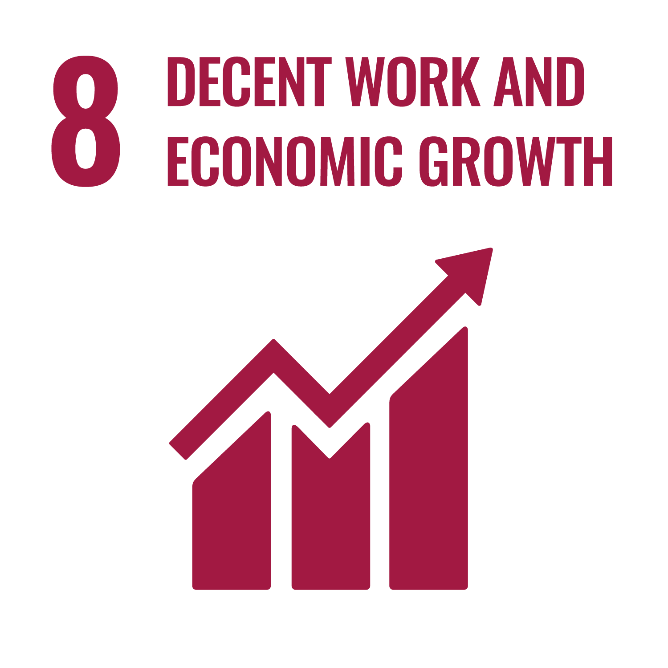 | - SRHU ensures dignified employment through fair wages, gender equality, healthcare benefits, and anti-discrimination policies.  - Promotes entrepreneurship and economic resilience via rural development training, MSME partnerships, and incubation support.  - Offers 100+ skill-building programs in sectors like health, agriculture, and IT to enhance youth employability. | Decent Work and Economic Growth
SDG 9: Industry, Innovation, and Infrastructure  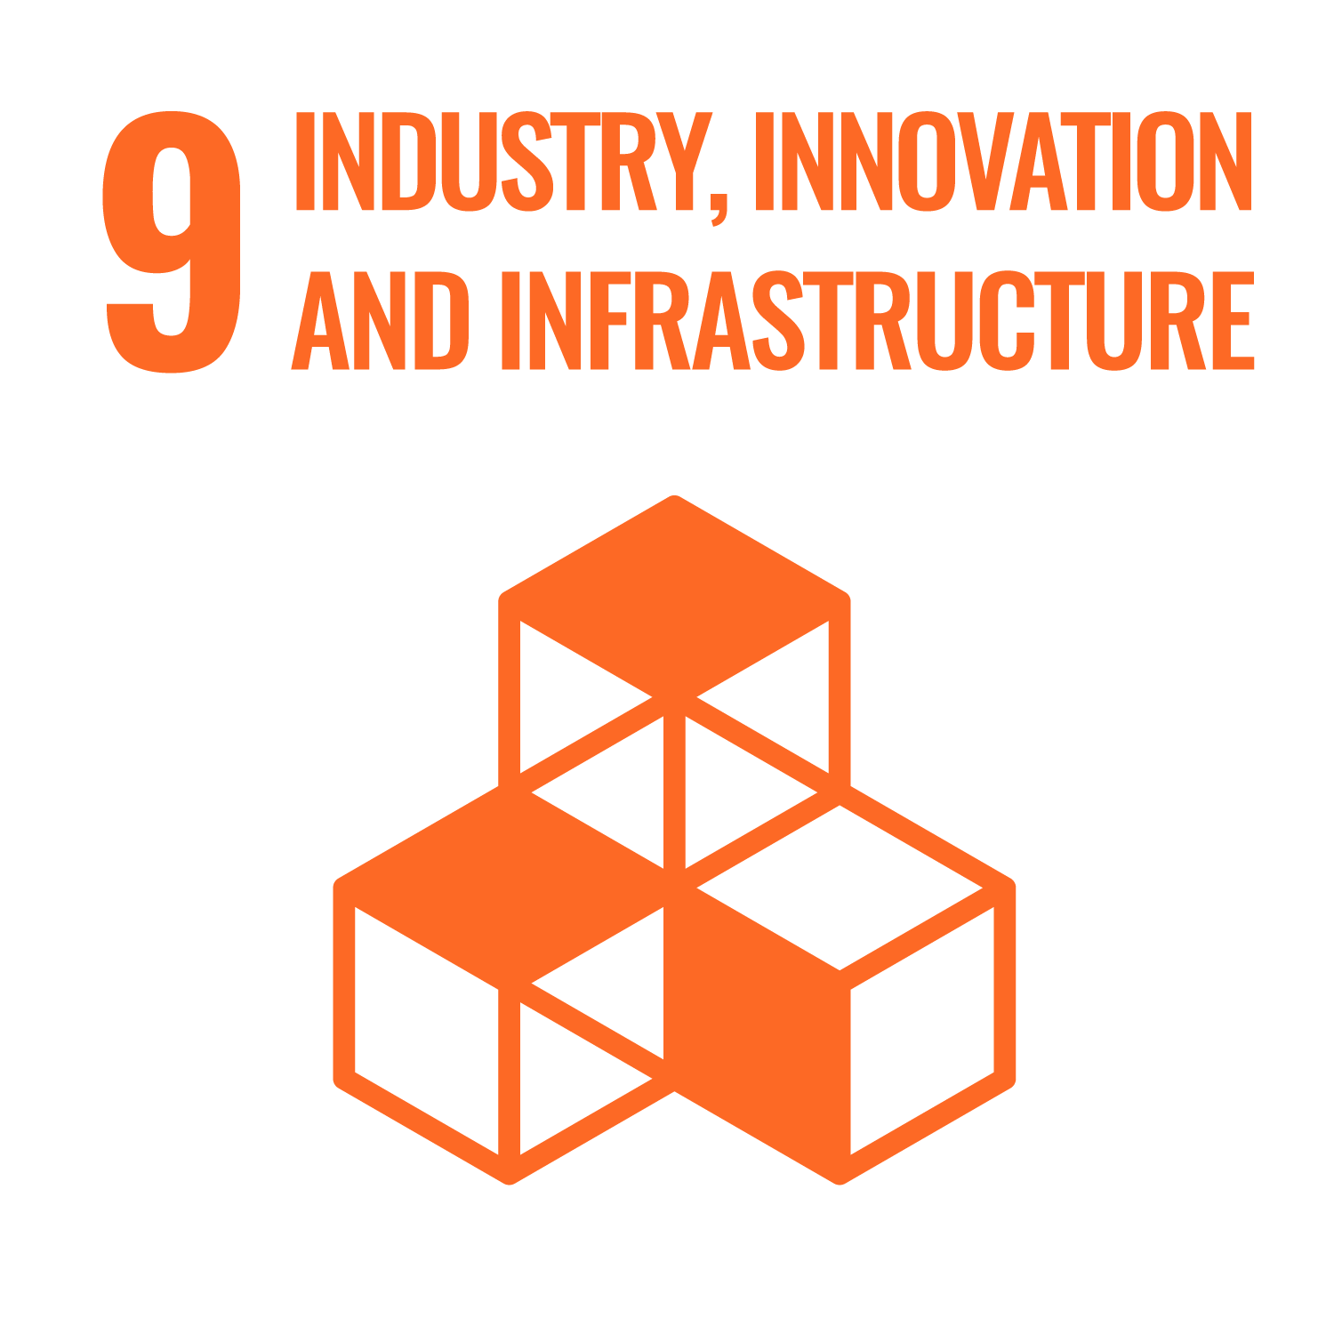 | - SRHU promotes innovation through 50+ funded research projects, patents, and an active Institutional Innovation Council.  - Strengthens rural infrastructure by training over 6,000 individuals in sanitation, water safety, and agricultural technologies.  - Builds industry-academia linkages through 30+ MoUs, technology transfer, and vocational labs for real-world problem solving.  - Champions inclusive infrastructure with accessible buildings, clean energy systems, and ICT-enabled smart classrooms. | Industry, Innovation and Infrastructure  Incubation Center  Sample Report on Awareness Session
SDG 10: Reduced Inequalities  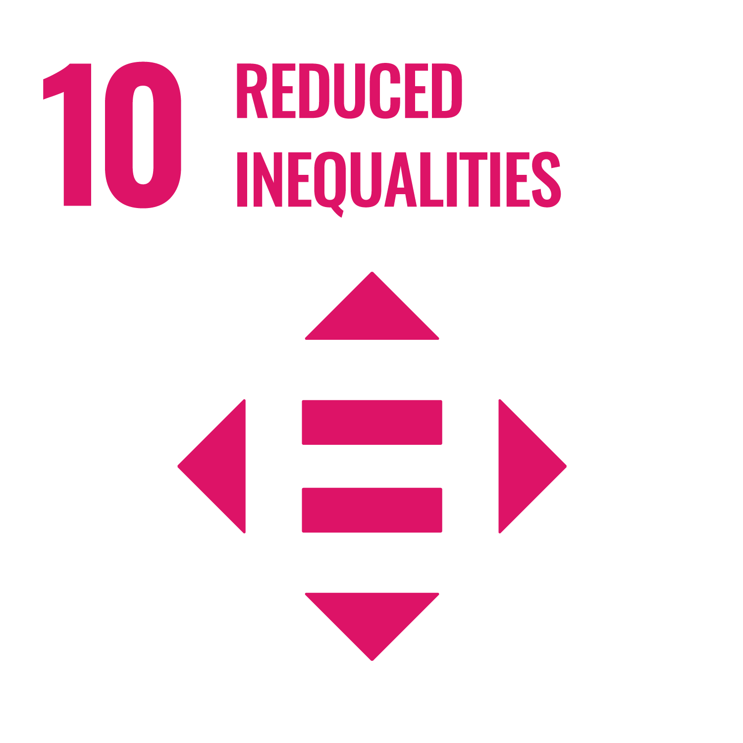 | - SRHU promotes equity through scholarships, fee waivers, and inclusive education for economically and socially disadvantaged groups.  - Offers special support for differently-abled students—ranging from assistive devices to inclusive infrastructure and career services.  - Fosters diversity via cultural celebrations, student clubs like YOUNITE, and a curriculum focused on empathy, social equity, and accessibility.  - Impactful research and outreach address systemic barriers in healthcare, education, and employment for marginalised communities. | Reduced Inequalities  YOUNITE
SDG 11: Sustainable Cities and Communities  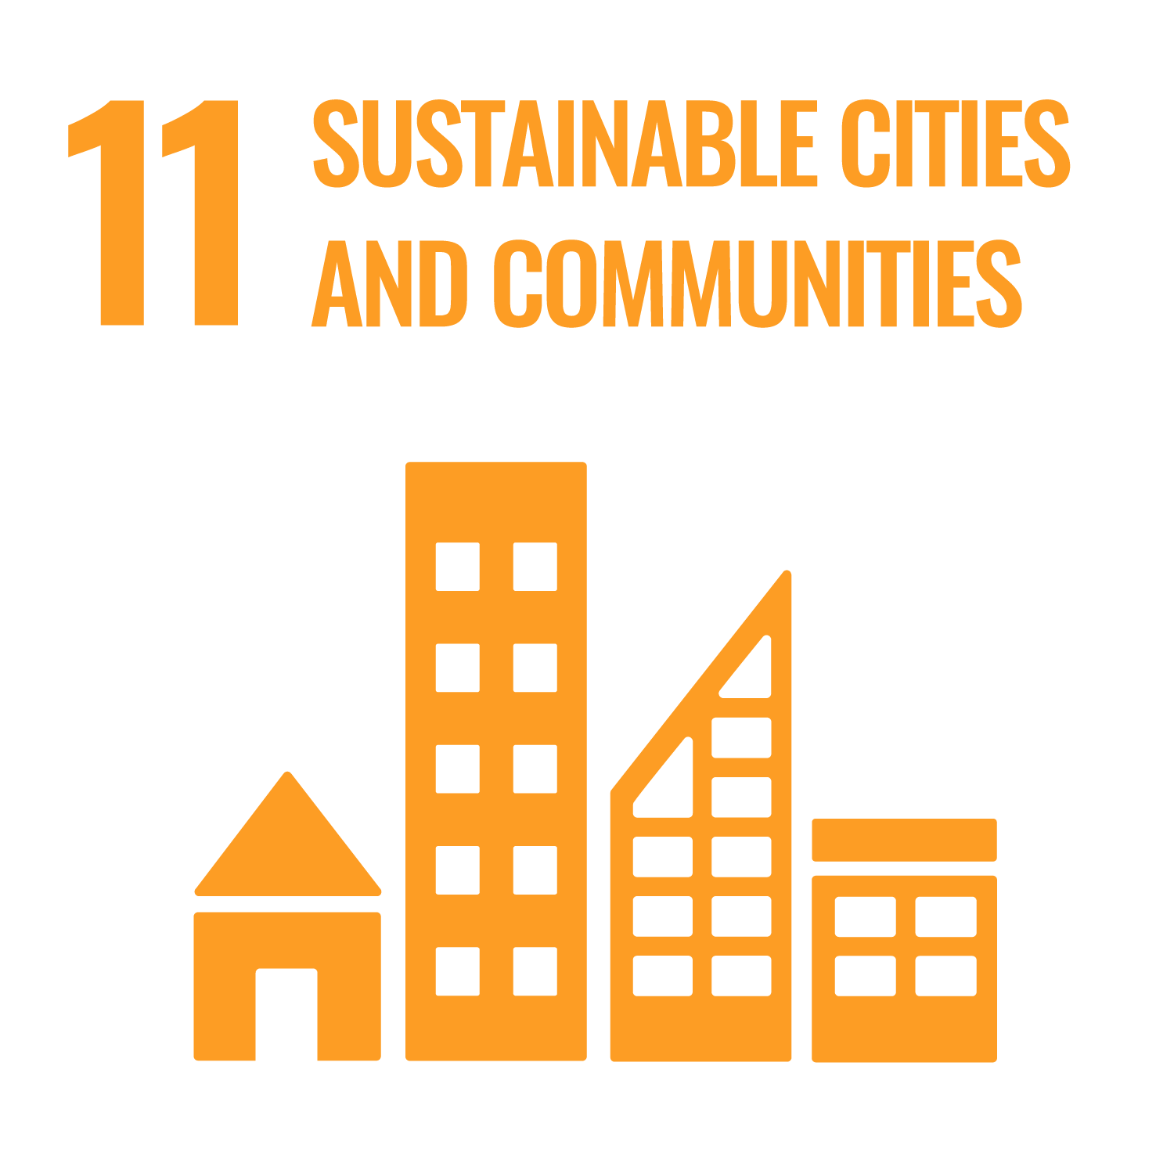 | - SRHU maintains a green, inclusive campus—plastic-free, disability-friendly, and rich in biodiversity with over 5,000 trees.  - Promotes community resilience through outreach programs in sanitation, safe housing, telemedicine, and disaster preparedness.  - Drives sustainability via solid waste management, low-emission transport, and renewable energy infrastructure.  - Conducts research and training for government officials and engineers on sustainable urban planning and water-safe infrastructure. | Sustainable Cities and Communities  Green Audit Certificate
SDG 12: Responsible Consumption and Production  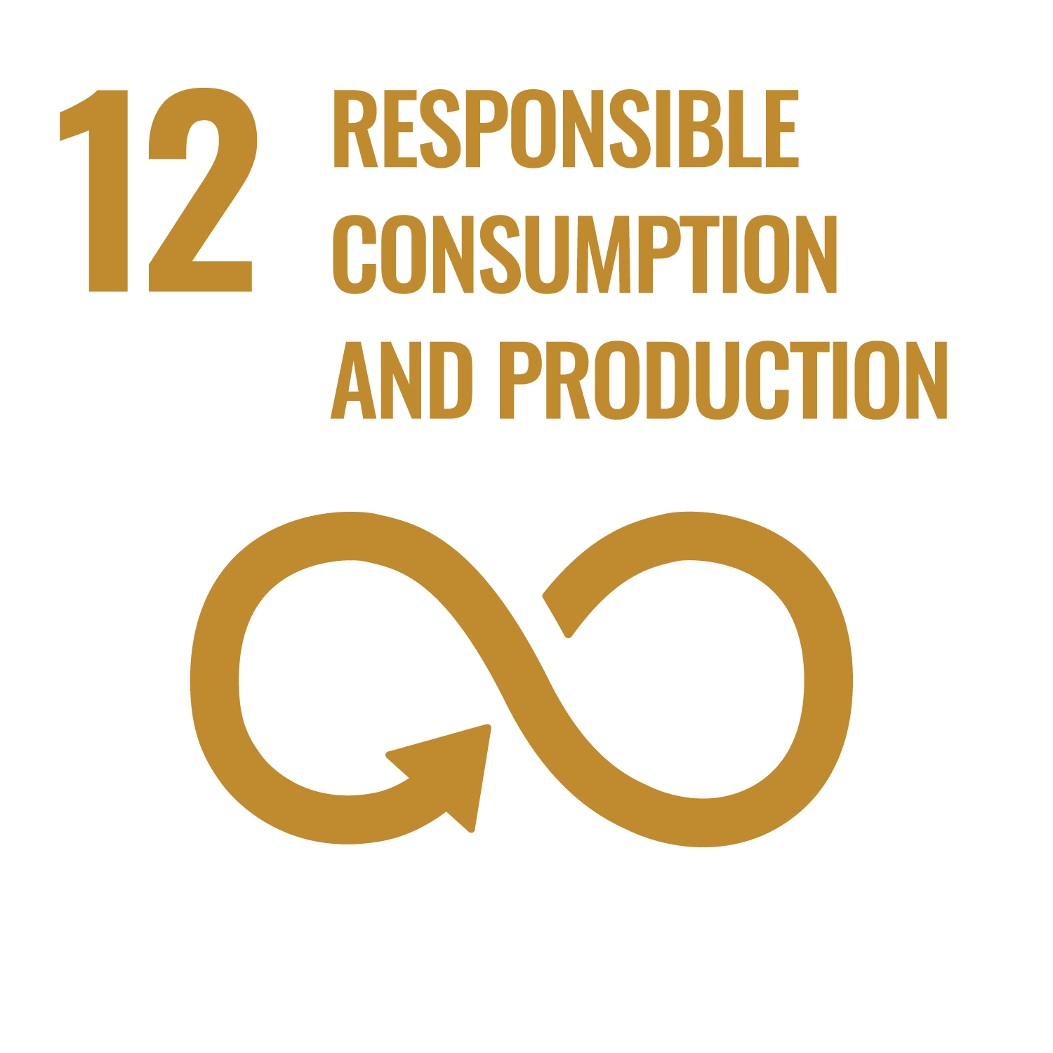 | - SRHU integrates sustainability into campus life through efficient waste management, solar energy, rainwater harvesting, and recycling systems.  - Promotes responsible practices among students and staff via green curricula, LED lighting, BLDC fans, and zero-plastic initiatives.  - Leads impactful research in water conservation, climate-smart technologies, and circular economy innovations like biogas and e-waste recycling.  - Certified for ISO 14001 and 50001, SRHU sets benchmarks in sustainable infrastructure and eco-conscious operations. | Responsible Consumption and Production  Water conservation practices at SRHU  Environment Management Certificate  Link for CII certificate
SDG 13: Climate Action  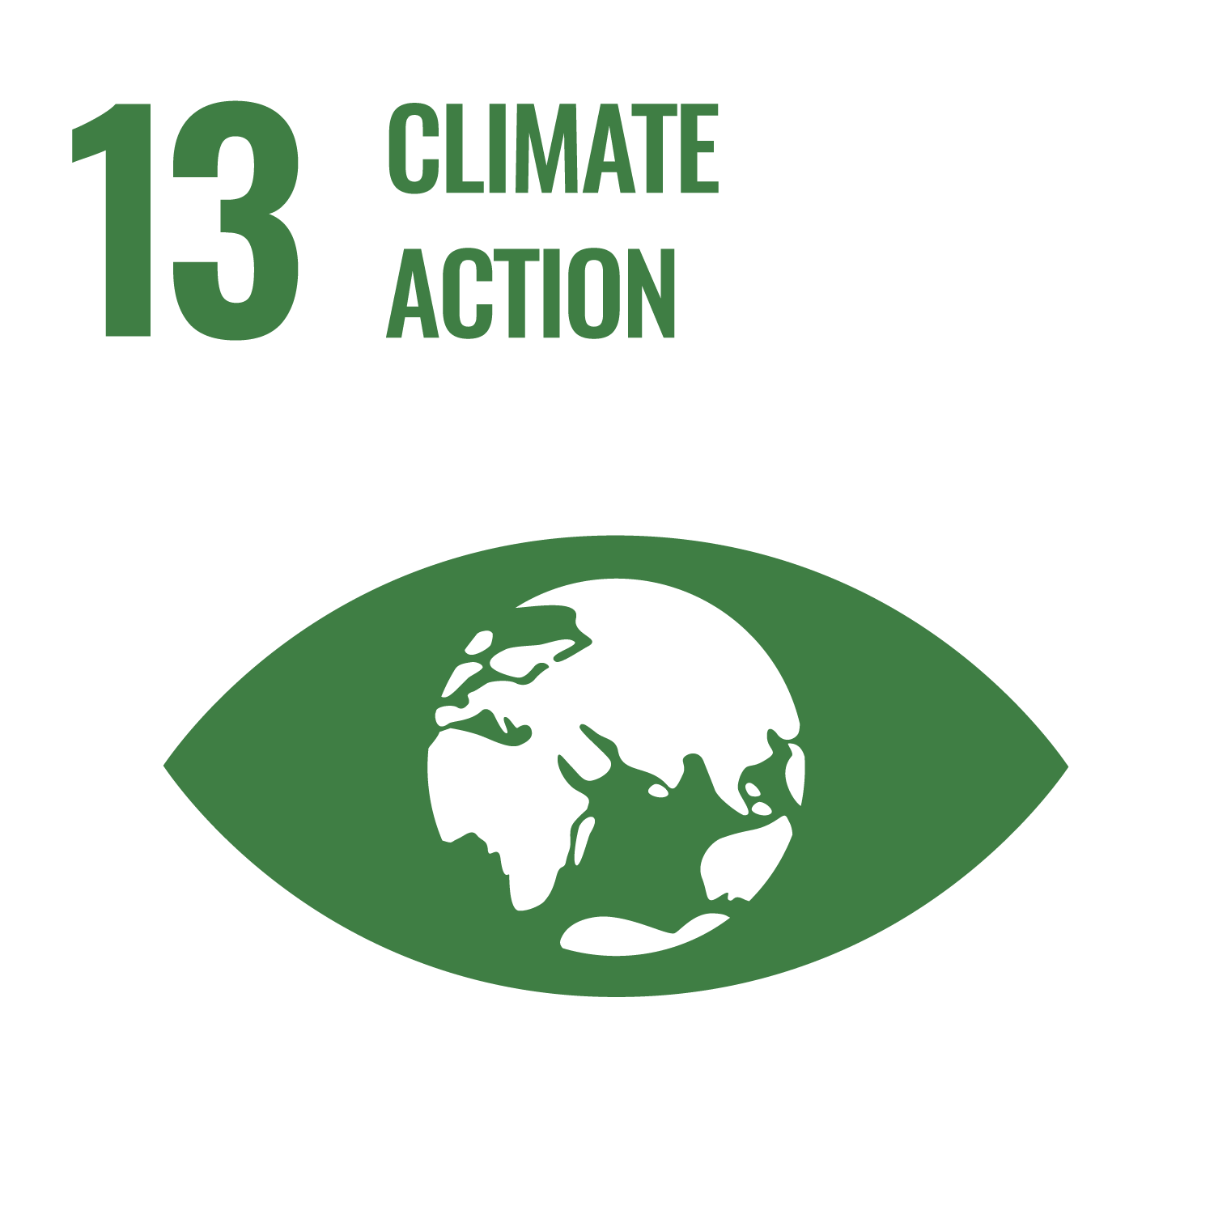 | - Swami Rama Himalayan University actively supports SDG-13 through impactful climate action and sustainability efforts.  - The campus features solar energy use, rainwater harvesting, waste reduction, and tree plantation drives.  - Sustainability is embedded in academics, research, and student engagement, fostering climate awareness and innovation.  - Through eco-friendly infrastructure and behavior change campaigns, SRHU sets an example of responsible environmental stewardship. | Climate Action  Link for certificate
SDG 14: Life Below Water  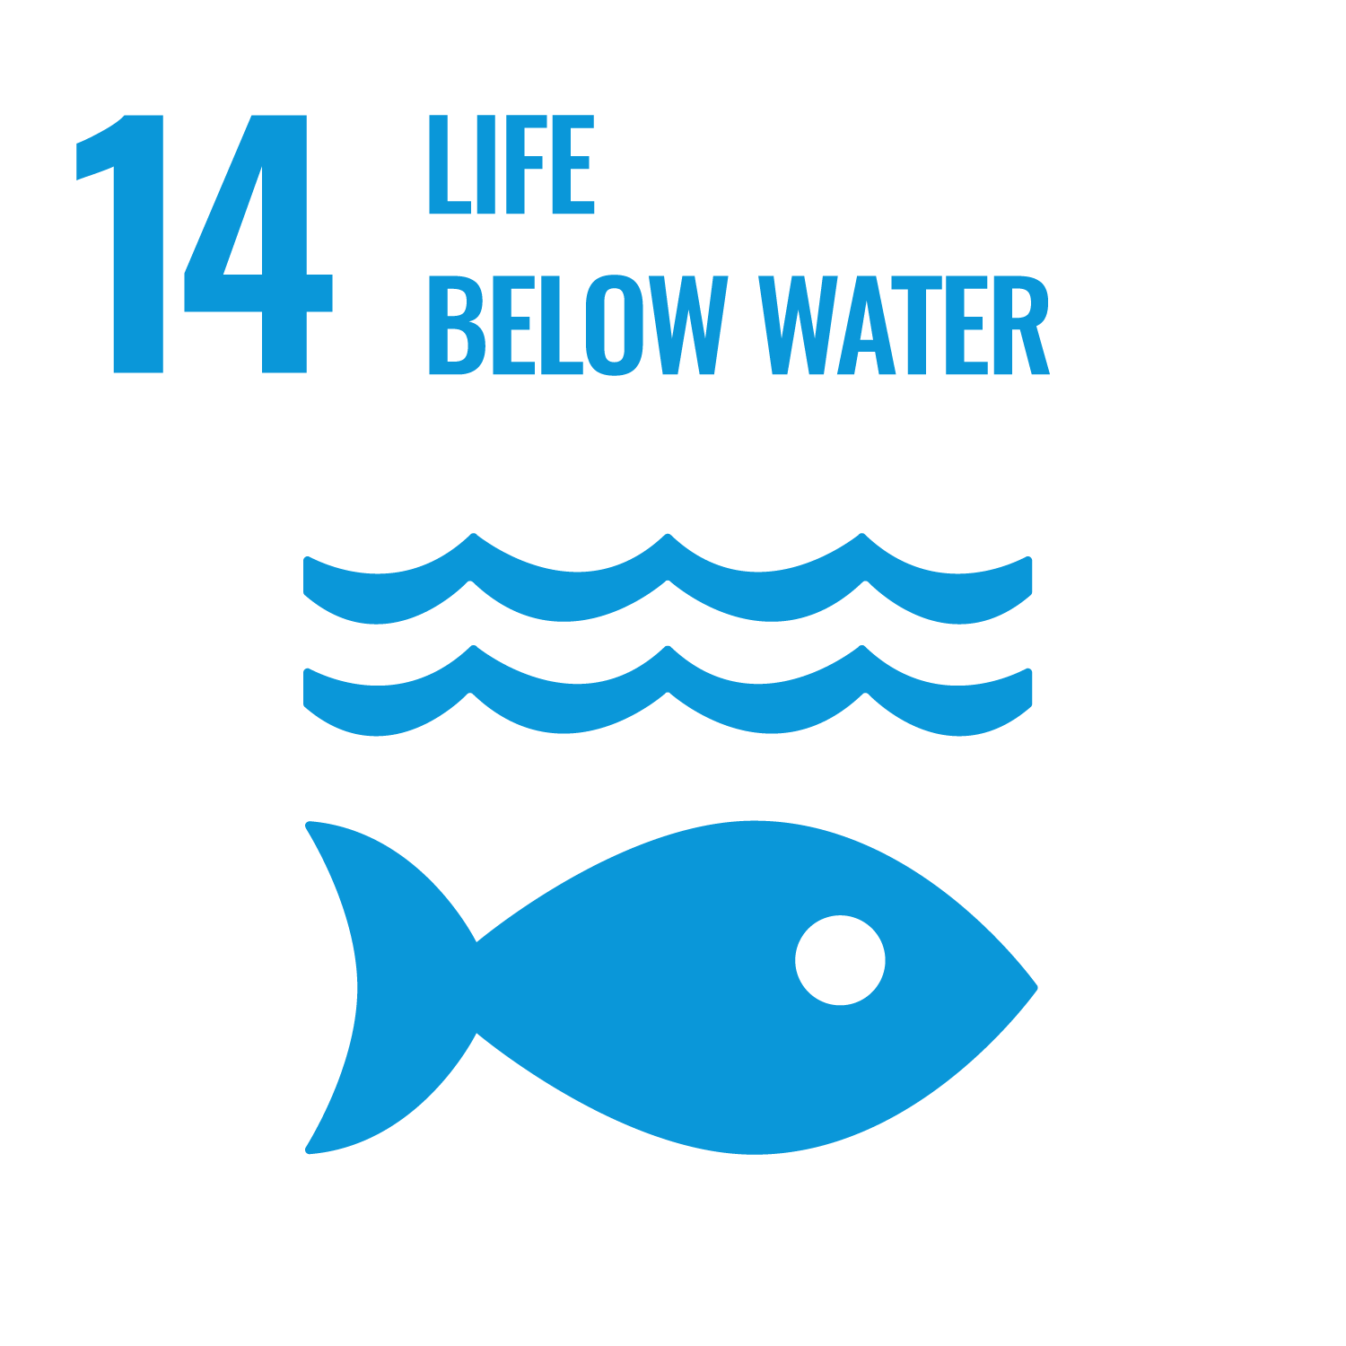 | - SRHU aligns with SDG-14 by promoting conservation of aquatic ecosystems through interdisciplinary education, research, and community outreach.  - The university tackles challenges like water pollution, overfishing, and habitat loss with research on sustainable aquaculture, pollution mitigation, and biodiversity preservation.  It funds projects and publishes actively on marine sustainability, microplastics, and innovative water management solutions. | Life Below Water
SDG 15: Life on Land  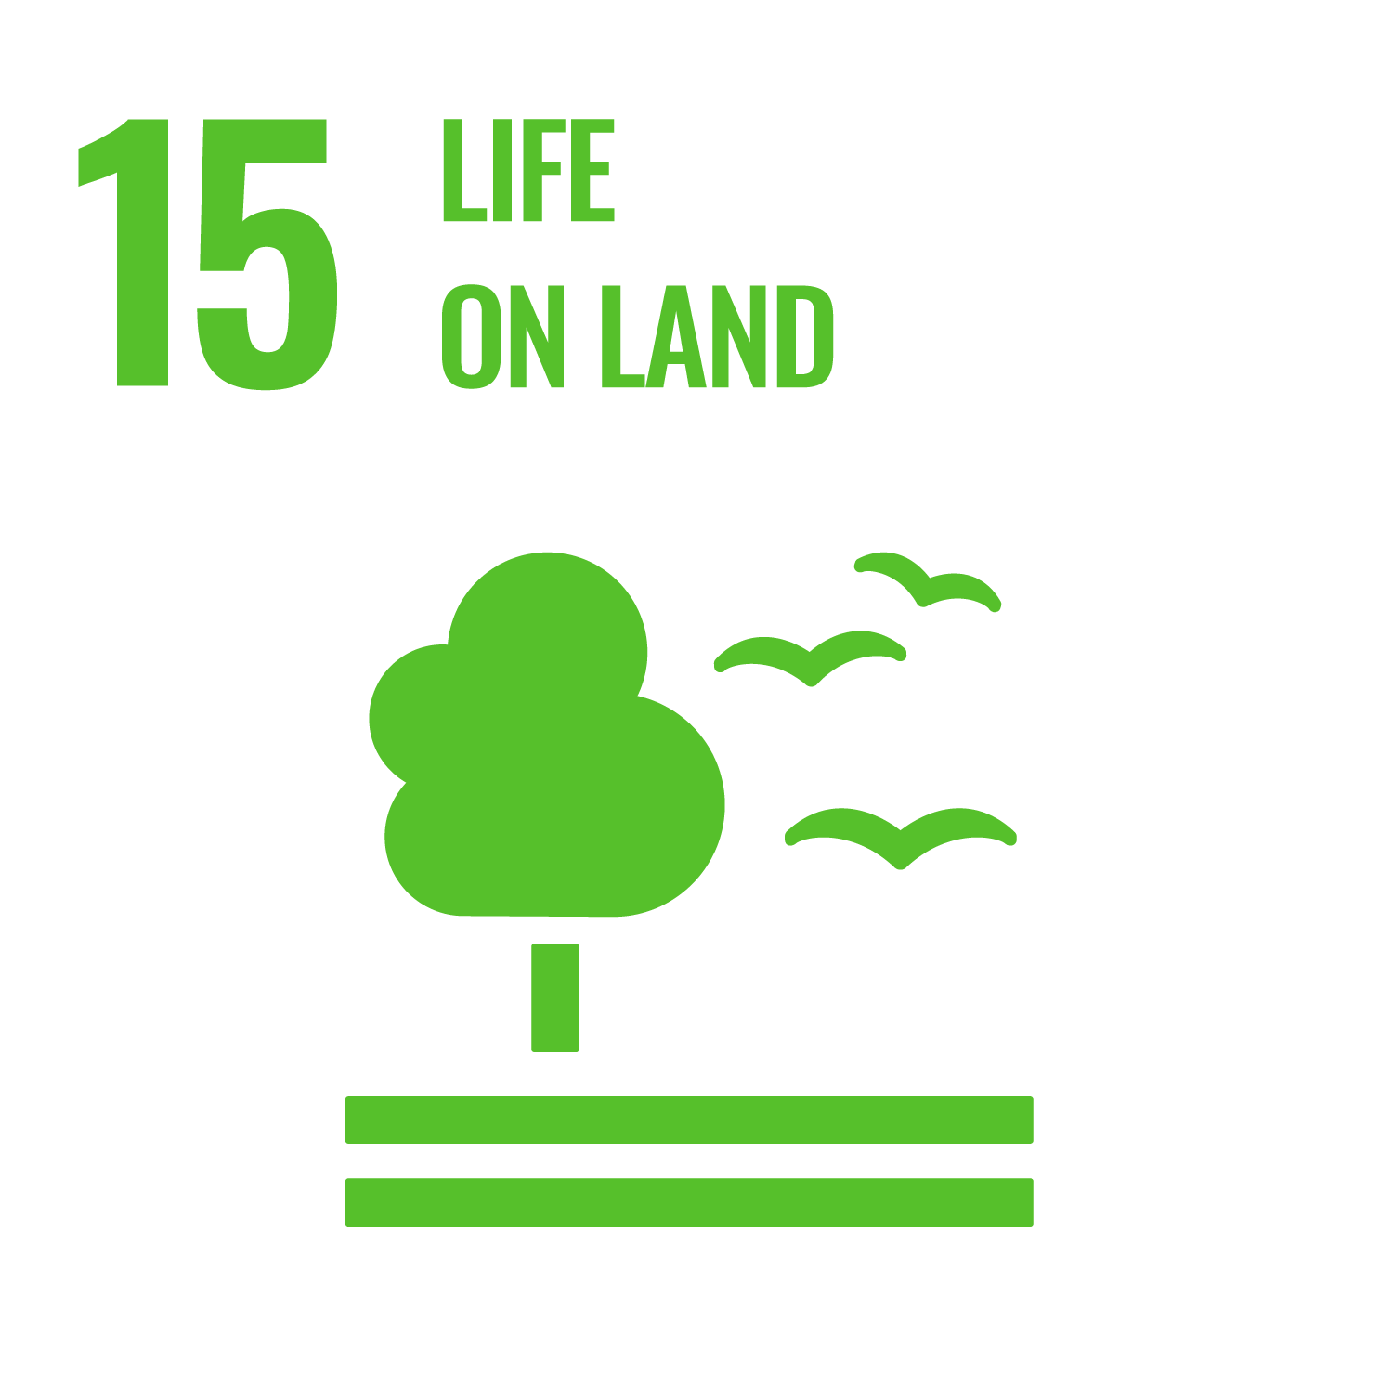 | - SRHU actively promotes biodiversity, eco-restoration, and sustainable land use through tree plantations, green audits, and rainwater harvesting.  - The campus boasts over 5,000 trees, solar energy infrastructure, and extensive water and waste management systems supporting ecosystem health.  - Programs like plastic-free campus campaigns, e-waste recycling, and energy-efficient buildings underscore SRHU’s green commitment.  - Recognised with national awards, SRHU integrates environmental stewardship into academics, community outreach, and daily operations. | Life on Land  Link for CII Platinum Award certificate
SDG 16: Peace, Justice, and Strong Institutions  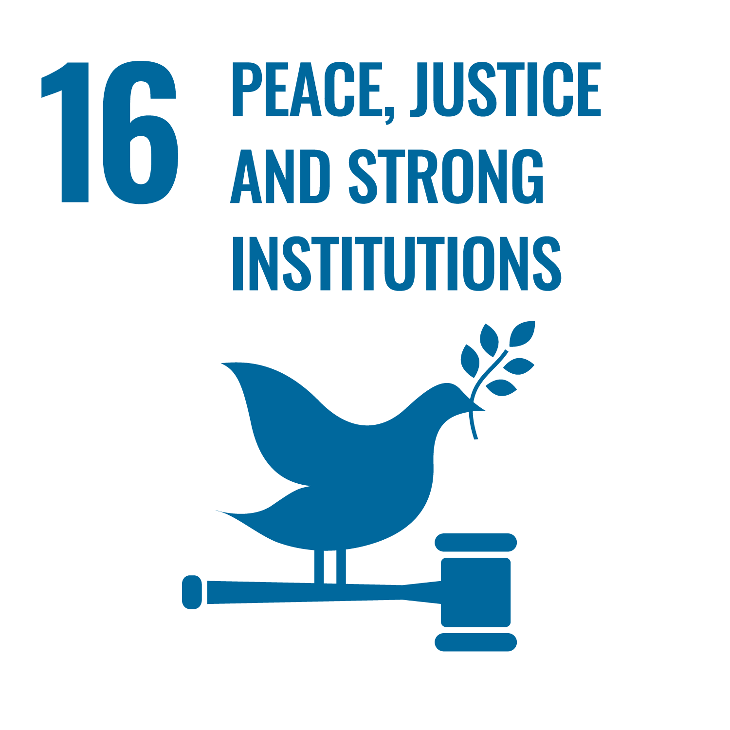 | - SRHU fosters peace, justice, and strong institutional values through transparent governance, ethical research, and inclusive education policies.  - The university upholds integrity with strict anti-plagiarism rules, a code of ethics, and zero-tolerance policies on misconduct and harassment.  - It actively engages with communities via outreach programs and supports equitable access to education through scholarships and financial aid.  - Facilities like the Cadaveric Lab and Skill Simulation Centre promote ethical, skill-based medical training, advancing justice in healthcare delivery. | Peace, Justice, and Strong Institutions
SDG 17: Partnerships for the Goals  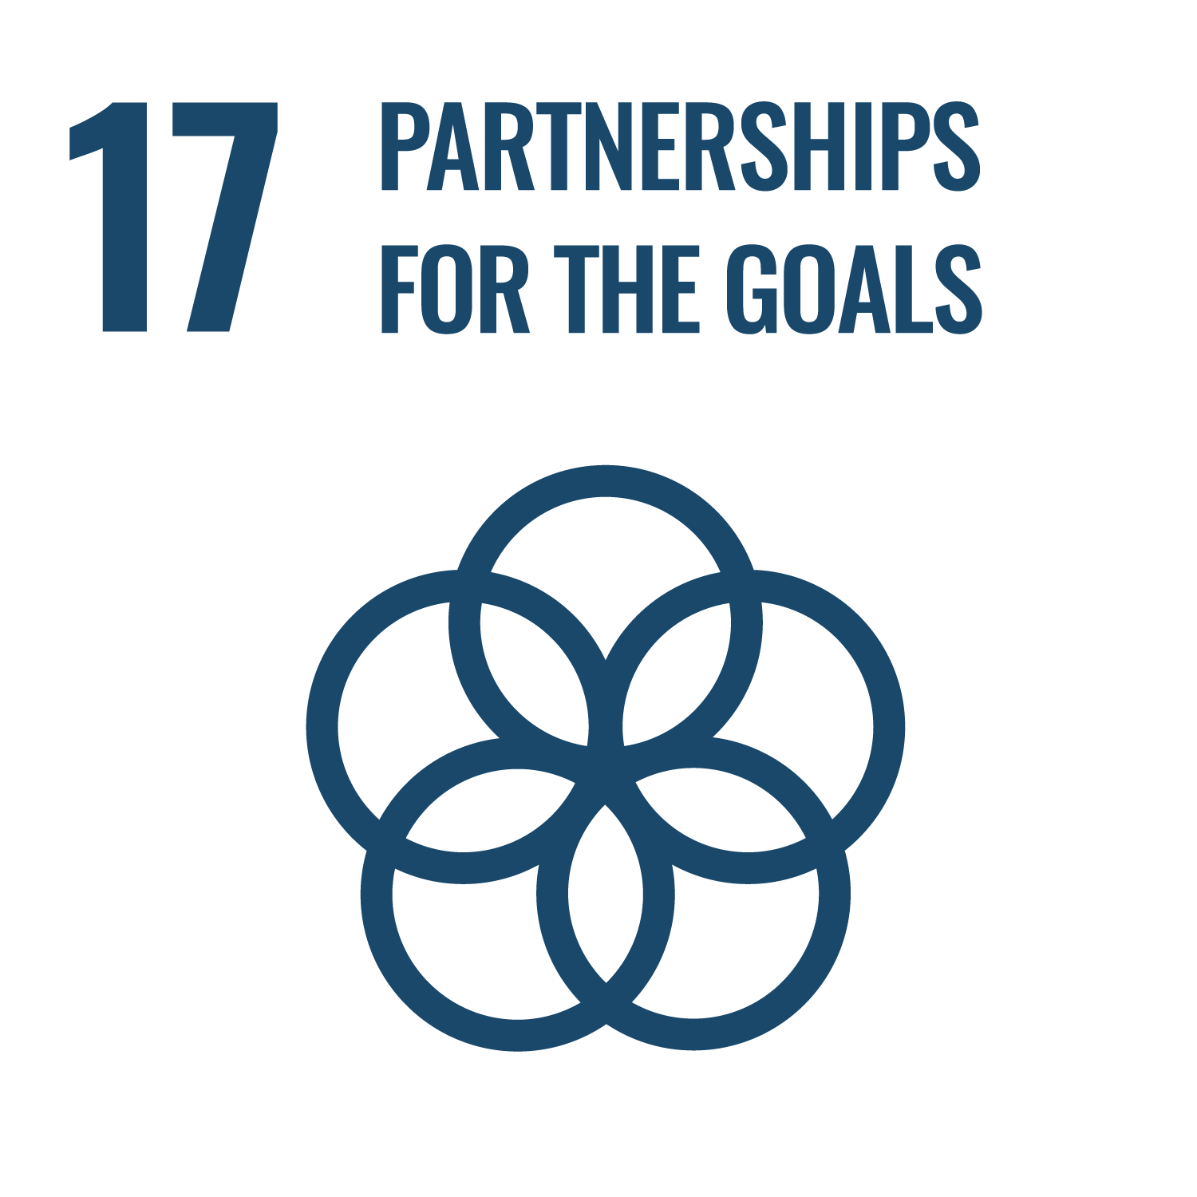 | - SRHU fosters impactful partnerships across academia, government, industry, and international bodies to drive sustainable development and innovation.  - The university has trained over 9,000 individuals in water, sanitation, and livelihood programs, and supported 30,000+ people through healthcare and disaster relief efforts.  - Through MoUs with institutions like AIIMS, ICMR, IIT Roorkee, and global consortia, SRHU promotes collaborative research and global knowledge exchange.  - Incubation hubs, capacity-building programs, and inclusive community outreach make SRHU a regional leader in achieving SDG-17 and empowering social transformation. | Partnership for goals

